The Verstraete Venture

The Verstraete Family’s
Immigration in
1958

By

Chris Verstraete

Admiral Press

…..Children ought to know where their parents come from…..

®1979 by Chris Verstraete All rights reserved
Limited edition of 65 copies of which this is copy no.
Printed and bound in Canada
Admiral Press
106 Albert Street
Point Edward, Ontario N7V1R3

Contents Page 5
Preface………………………………………………………………… 7
In Montreal 9
Landed Immigrants - stranded
in farmers land 13
Planning emigration, then pulling
up stakes and roots 25
Half a dozen and one extra 37
Canadians by choice and by birth 47
Index of Pictures 51
Appendices 53

Preface -7-
This book has been written with
the sincere hope that our family and
its descendents always will remember with love
all persons connected with them
through family ties.
I like to thank all who have helped in putting
this book together. In this regard I will not
mention names except one, my wife, your mother and
grandmother, Cornelia. With an unbelievable memory for
facts, she has made possible to record many happenings the recollection
of which otherwise would have been
lost in time.
Chris Verstraete Point Edward, Ontario Fall, 1979

In Montreal -9-
On the eighth day of June, 1959, the Verstraete family of eight persons had become Canada Landed Immigrants and had their passports stamped accordingly.
This fact actually had happened aboard the Holland America Line s.s. "Waterman", a ship upon which one is on Dutch territory as international laws stipulate.
After leaving Holland via the port of Rotterdam and a good week's time of crossing the Atlantic Ocean we had entered the St. Lawrence estuary. To come so close to the shore of Canada, that dreamt-of country was seen as a real thing and that happening was for almost every immigrant aboard the ship an emotional and never-to-be forgotten experience. A day before we had barely seen the first glimpse of Canada. Wrapped in foggy and cold weather we had observed the most southern tip of Newfoundland, Cape Race. For us it was Canada, but the weather conditions didn't make the first sight a first love. After having seen that extreme point of Canada's most eastern province for only a short time, the cape vanished and was lost on the northern horizon while the "Waterman" had continued plowing the ocean.
But changes were ahead of us. First it was felt that the waters were less rolling. No land was in sight yet, but the waves of the ocean changed to the calmer waters of the Gulf of St. Lawrence. Although the wind was very strong, the water was not that much of an influence anymore for an ocean-going vessel. Then on the horizon again appeared land. The mountains of the Gaspe peninsula became visible and we were coming closer and closer to that beautiful gateway to the country. Then on the northern side also land became visible and we had Canada all around us. At a place called Father's Point a small boat came to our ship and brought aboard the pilot. The sailing distance was still a long way and with less speed the ship worked its way towards the City of Quebec. We could see on the shores of the gulf the highway and between small villages located there, the cars moving from one place to another.
We had read that several Canadian highways were still gravel roads at that time, and now we saw the results of such a road condition: cars with long trails of dust. From far away it looked beautiful, far more beautiful than we would experience ourselves at later dates when we drove along similar roads behind another car or truck.
During the time we travelled the St. Lawrence Waterway the deckhands of the ship had begun bringing the passengers' suitcases and other luggage to the open deck of the ship. There was still a very strong wind and therefore that service was not appreciated by everyone whose luggage was brought to the deck and left without further attention to the wind.Those people saw parts of their clothing, blankets, and light-weight articles being picked up by the wind and blown into the water beyond reach. Large nets were put over the piles of luggage, too late for many pieces of personal articles brought along from the old country and now lost forever in the new one, even before we'd stepped ashore. The s.s. "Waterman'' made a brief stop at the port of Quebec. Only a few people left the ship at this harbour and we, with the remaining large number of Dutch emigrants, stayed aboard to disembark at Montreal.

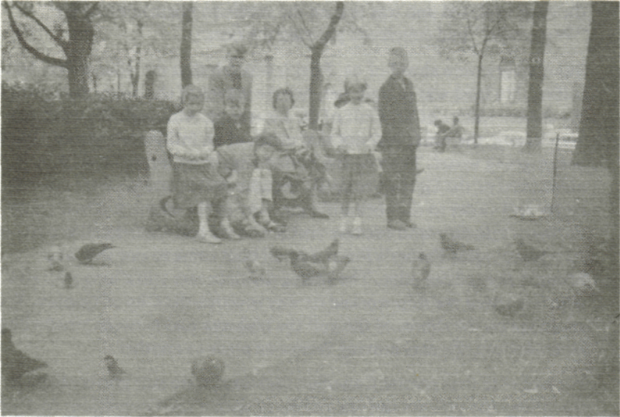

. Times and good weather were in our favour in Montreal and before a train was to take us from there westbound we spent several hours in a nice city park. At neighbouring stores we tested our English and had been courteously served in the French language. That worked out very well for us and as a family that didn't like to waste money, we most economically bought a loaf of bread, some buns, butter, cheese and milk and therewith enjoyed our first picnic in a Canadian park. An odd passerby would nod and with doves visiting us continually for being fed pieces of our bread, the outdoor meal became a most pleasant one. After we had had a floor under our feet when aboard the "Waterman" which had rolled at the whim of wind and water, we had now solid soil to plant our legs firmly upon.
For all eight of us relaxing hours in the Montreal park are really times to remember. Some hadn't fared too well when crossing the ocean. We had had some rough weather and with the port-holes all closed as a precaution against the elements, in the ship's dining room the soup on the plates had shifted from side to side on the tables of the few people who still wished to have a meal served. The bath towels hanging on our cabin walls had swung like a lazy pendulum, and several members of our family had frequently used the appropriate brown bags for the return of disagreeable food. Being back on land in Montreal we could far more easily adjust ourselves to a landlife than a week before and during storms to being sailors of the sea.

After the good times in Montreal we boarded in the afternoon a special immigrants train to Toronto. The train was not one of the beautiful ones always pictured in tourist promotions. We were shown to a train which had seen its best days, probably in the early years of immigration, and thereafter also had been used during the depression years for bringing back and forth people who thought that work could be available in places far from where they lived. We didn't complain about the train, but something was wrong. We were immigrants, that's correct, but we travelled with tickets paid for in full in Holland. We were not asking for free rides at somebody's else expense. It's all long ago now but once in a while the memory comes back, especially when we again have the experience that the trains we use today are not great ones. Although it had been said that train service had tremendously helped making Canada great, it was not the other way around: Canada hadn't made a great train service.

The sight-seeing of the country through the not-too-clean train windows was beautiful. Travelling from Montreal to Toronto we saw the fine-looking scenery of the Canadian Shield.
That made up a lot for the train interior with dirty washrooms, bad seats, drafty doors, messy floors. At dusk we entered the city of Toronto and for us in the strange and dimly lit Union Station we transferred to a somewhat better looking train with as our final destination Chatham-Wallaceburg, Ontario.

Landed in farm*

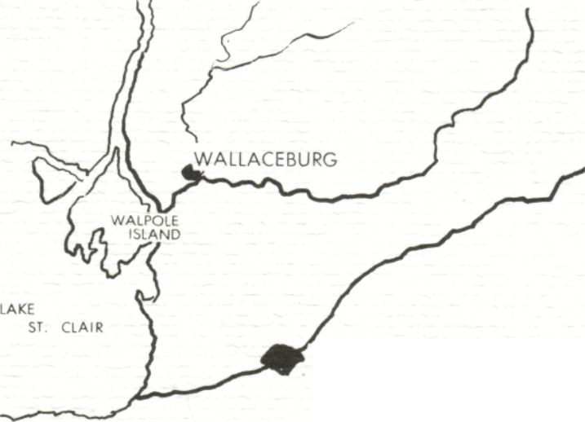
CHATHAM

Landed Immigrants - stranded in farmers land -13-
The decision to go to the town of Wallaceburg, Ontario, had been a result of the advice to us from the Christian Reformed Church Immigration Commission for Canada. The contact with that commission had come after many requests for information we had given to the Christian Emigration Centre, through its Overijssel, the Netherlands, office. Both official offices had been fully informed by us to what and who we were, and what we expected. Throughout our very many personal visits to the Dutch office and our correspondence with the Canadian officials they had been informed in detail what our qualifications and expectations included: they had a good insight into our family.

Many people have asked at later times, why had the officials taken the responsibility of advising a middle-class family like ours to go to a farmers community and place like Wallaceburg. I met there people of Dutch origin who also emigrated to the same town and had never seen in ttett l\fe, fot example,, a train, interior until they had to travel to The Hague, Holland, for an examination at the Canadian Embassy Immigration Department.

I'll never say or even slightly suggest that the characters of these people were of a lower level or that they were less civilized than what I ever could expect from people who had the courage to emigrate to another world, but many would agree that they had lived lives different from ours. For us, who liked intellectual stimulation just as much as we had an interest in material things, it had been difficult to find suitable subjects for an evening of conservation with many people whom were introduced to us in and around Wallaceburg.

Some conflicting interests are well illustrated with when, for example, several people of the local church looked at me, even talked to me about what I was doing, when I, at local bookstores, went through the racks of paperback editions in search for some literature. To them a paperback did not mean a convenient low cost edition of a hardbound book of good literature but rather a book of questionable quality writing.
In Holland we had always loved to take our children, as young as they were, to art classes, extra-curiculum foreign language classes and to travel by train or with our auto to places and people. With the children we had made trips to the unspoiled woods during the weekends and there we would eat, play, or do nothing at all except relax. It was like my parents had done during the twenties and the thirties with me and my brothers. In my younger years I had been taken by my parents in my father's automobile to family, friends, outings and events all over the place. I still remember the automobiles my father had and with which we had so many good times: the 1928 black Ford, the 1932 maroon Citroen, then the 1936 dark blue, two door Ford V8, all of them used intensively for business and pleasure.
In our matter of emigration we were advised to go to a community where, we would experience, during the early summer time most conversation would concentrate on how fast a dollar could be made in blocking sugarbeets. During the late summer the topics turned to picking strawberries or tomatoes and for the rest of the year important talk would be about cleaning houses and offices to supplement family incomes.
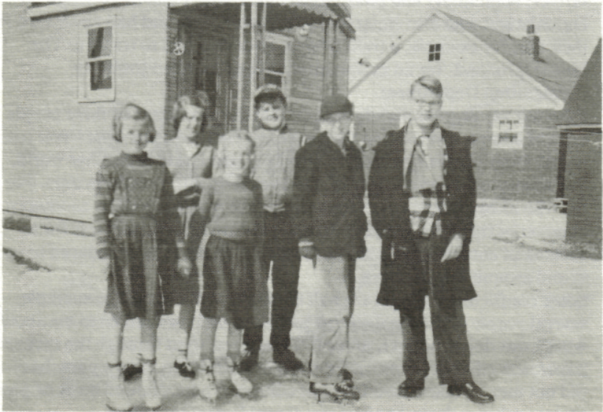

It must have been most difficult for our children to adjust, too, then aged from seven to fourteen years old. They had been taken away from loving grand-parents, friends, schools, clubs, their neighbourhood, and even their language. They were taken to a place where children introduced to them would show interest in pulling weeds from soybean fields, pick only for financial interest the fruits of the season, raise or helped raising animals for slaughter. They were brought to schools where teachers spoke a different language and where everything and everybody was strange. At such times our children could have had many reasons to love their parents less than before, because what the children experienced and went through with, was a result of their parents' choice to emigrate. It will be difficult for a family like yours to find a house in Wallaceburg, but work is plenty available and no problem, and the place is growing fast. That had been written to us in letters we had received from the Christian Reformed Church immigration people. Guided by such statements we had accepted the sponsorship of the Wallaceburg local church and upon arriving there we would find things to be quite different.
Very soon, almost at the first day after our arrival, we had found a house in Wallaceburg, paid a month's rent in advance and took over from the owner for a steep price the space heater for the whole house and a large cooking stove in the kitchen. The house owner was transferred to another town and after he had moved out we could move in. But in order to do so we still had to wait for our crates with furniture which were to come via the train from Montreal. And, as we were sponsored by the church, we could sleep for free in the church basement on borrowed bedding until we had set up our family in the rental.
Finding suitable work, however, turned out to be quite a different story. Because of my knowledge and experience in the graphic industries in the Netherlands, I tried many printers in the area for work and some bookbinding companies further away. There was no work. Trying to find other sources of income, I called on building contractors but they almost didn't build. I paid visits to local factories for work, but there were no openings. Many factory workers had been laid off and would be hired back before I could have a change. Some friendly people from Wallaceburg took me to other places in the area but there also was not even a hope for a promise. Beside the fact that there simply was no work available while we had been assured there was plenty, in other matters

also, the arrival and first weeks in Wallaceburg were largely a disillusionment. We had left Holland, a flat country with canals, rivers, grass and well-known for rainy weather in such a degree that for centuries it had been labelled frog-land. Then we came in Wallaceburg, in the middle of a flat country with canals, rivers, grass, rain and mud when we arrived, and as a result from humidity, mosquitos in quantities as we'd never seen before. Holland was still attractive with clean streets and sidewalks, Wallaceburg of that time is still remembered for the streets with potholes, many without any good pavement at all, broken sidewalks or streets without sidewalks. And rain turning boulevards and everything into mud, breeding-places for more mosquitos.
I had travelled a lot in my life, to cities large and small, to towns and villages all over in the Netherlands, over highways and had gone along small paths which were cleared over the centuries as shortcuts through rural areas. But never in my life have I had to scrape so much mud and clay from my shoes and boots as during the years we lived and spent in the Wallaceburg area.

The first work I found in Canada was thinning out, hoeing sugarbeets amidst the Indians on Walpole Island, a reservation near Wallaceburg. Did the small plants which I had to tend ever grow low to the ground and in rows miles and miles long! During the couple of days I worked there the sun was out in a blue sky. Did I ever, at that time, enjoy the abundance of a bright sun and the healthy climate of Canada, working a suntan on myself as I hadn't had for a long time! It was for the good luck of my back that the work was finished in a few days time.
After the brief spell of field work near Wallaceburg, I had the 'privilege' to have been given a temporary job, a couple of days tearing down a part of a chemical industry building located many more miles away. After each day's work all the scrap and junk was taken from there and trucked to a farm near Wallaceburg, except for all the pieces we continually lost on the way home along the St. Clair River. I was really surprised that the truck drivers never had been stopped by the police, for the highway was for about thirty miles littered with plywood, sheetmetal, nails, two-by-fours, electrical wiring, etc. Canada really then seemed to me to be a country of free enterprise.

Following the wrecking business I found a building contractor whose carpenter had gotten sick and, I was told, another one was needed. With my brief demolition experience I told the man in charge I could handle a hammer and was willing to work. I owned some good carpenters tools and that might have made a good impression. To my surprise I was hired on the spot at the for Wallaceburg high wages of $ 1.25 per hour. After working a few weeks with blisters in my hands, comparable in size and shape to quarters and ping-pong balls, I had adjusted myself to the work with studs, beams, nails, sheating, singles, doors, windows, insulation, trimming, painting, making cabinets, and I don't know what all else. During the winter months of the first year I applied my familiarity with the home building and home improvement trade to the decoration and improvement of the local church and the parsonage, which had become vacant just before our arrival in Wallaceburg. It was a very much needed job and with my re-modelling, carpentry, and painting experience the appearance of both interiors became more attractive and desirable. The church, which had sponsored me and my family and which already seriously pressed for monetary support from my side, was now receiving good work for which they paid forty cents per hour, But even those few dimes became too much, because after some weeks' work I was told by a church board member that I should quit the job. Some church people were even jealous of that small amount of money paid out of the church coffers.

At those times the official relation between employer and employee in Canada was still at a stage that had to be much improved. Once I was working for many months for a construction company in Chatham, Ontario. It was in the fall and during an afternoon when everybody was busy with his work, the 'old' boss, who officially was retired but in fact was running back and forth between construction places from morning to evening, came unexpectedly up on the roof of one of the houses we were building, to tell me my work was ended. A year before on that occasion I was working in Dresden, Ontario, and then another employer dropped in during lunchtime to tell me I was laid off immediately and didn't have to work for him anymore in the afternoon. He hired me again next spring, however, when more work was coming up. Once, when working for an employer in Port Lambton, Ontario, I was also laid off when the winter was coming and I asked him about my vacation pay which Ontario labour laws had just made mandatory. He laughed about it, and I never received that pay.

The evening hours I had always used in search for people and places to buy graphic equipment and materials. My employment in the construction was kept on for a couple of years to supply a convenient income during eight or nine months of a year. We used unemployment insurance money and savings during the first winter to buy, beside the bare necessities of life, a good car and more equipment and materials for the business I had started myself.

Early records are still kept as mementos and show the first transactions and things bought, and that within six weeks after landing in Montreal I myself was in business again in Wallaceburg.
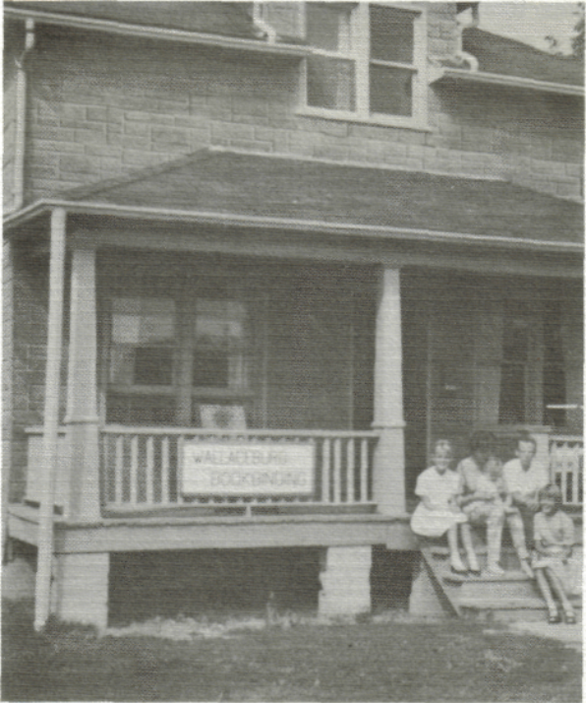

During the beginning period of that business of bookbinding there, many things were done with a lot of improvisation. For example finished books were being pressed under the weight of our heavy piano. I would lift the instrument and my wife would place under it the books between boards for pressing and drying.
From the very beginning of our enterprise and onward things went well. Good contacts were made for sales and services to customers many miles away. The business kept growing, still more professional equipment and tools were bought and in early spring, 1959, my expanding business was getting to be well-known under the name 'Wallaceburg Bookbinding', planting its roots deeper and deeper and showing all signs of further healthy development. It was too bad that then, mainly for the purpose of a greater sales promotion, I became involved in a business partnership that ultimately would end in a great disappointment.

The new Wallaceburg Bookbinding business had begun to burst at the seams. Binding orders had been booked from across the province and even from places far beyond its borders. Other quarters had been acquired and people who had never realized that books were bound, had to be trained to become bookbinders, case-makers, and special printers. Persons previously employed in local garages had become managers and foremen in an industry they had never heard of before. People who after some training thought they could already manage in bookbinding business erred during business meetings in their understanding that binding paperbacks was binding paper bags together; when asked about the number of signatures in a book, they thought about an autographing party; when asked about case binding, they confused it with a book case with shelves of bound books.

The bookbinding business in Wallaceburg had come to be taken as an example of what an immigrant could do with skill, knowledge, and perseverence. Even dignitaries from the Netherlands, when travelling through North America, found time to visit the bookbinding industry and for that reason made detours when travelling near New York, U.S.A. That I had been an immigrant didn't matter anymore. The company's regular pay cheques for a good size staff were far more important and locally it was much appreciated that the sources of the money were in other cities and towns and was most secure. Everything was steadily increasing in volume to everybody's satisfaction. But, as mentioned before, the business partnership worked out the wrong way and as the result of a great disappointment in people we closed our Wallaceburg Bookbinding files, sold the interest I had in the company, and moved away from Wallaceburg to Point Edward, Ontario. There I successfully continued the Verstraete enterprises under the names Admiral Press and Admiral Bookbinding, specializing in design and manufacturing fine books in limited editions and also, as a paid hobby, the restoration and rebinding of books with a great value.

Dutch officials tour
local book industry - 22-
As peaceful and promising as our going to Wallaceburg had been, so great was our disillusion in some people there when we left. The years had been important ones in our lives. Our expectations had turned through hard work into a good business. Our children were growing up as young men and women, and they were attending universities and colleges in Canada and the United States of America, or when not at that age as yet, were students at Wallaceburg elementary and secondary schools. We were in a business we had grown up in, which we loved, an enterprise for which my family figuratively as well as in fact had laid the very corner stones, and to which it had given things and times never recorded or paid for.

In Wallaceburg we had many good times. We and our children had made good friends never to be forgotten. To the Town of Wallaceburg we had brought a new industry which the town's people never even had dreamed of before and which industry now will be in the town records forever. To the history of the Wallaceburg Christian Reformed Church we added a little history also. But in quantity it will never be as much as what I myself have written in that church's records. A registration of arrival and departure of church members had never been made, nor had births, deaths, and marriages been recorded, until I was elected and took office as the church secretary. Out of love for the church, and through countless interviews with older church members, from reading old bulletins and other papers and private correspondence of the church, I had compiled the facts and wrote them all down in new registers, beginning with the happenings of the church in its earliest days. Until I became the church secretary, minutes of official church meetings had never been written in the English language, and that had been changed too.

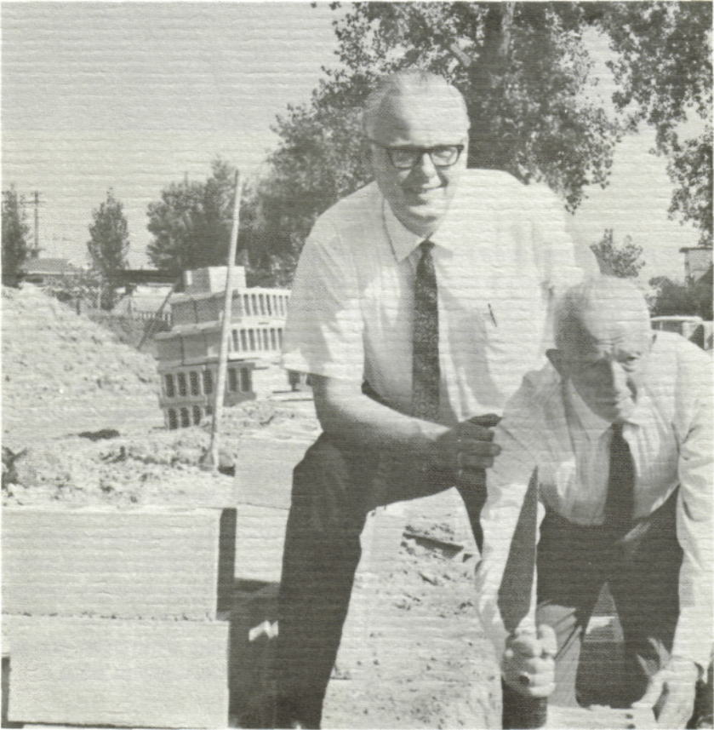

Planning emigration,
then pulling up stakes and roots - 25-
Leaving dirty body garments and underwear in the garbage on a trail stretching from the eastern parts of the Netherlands to the south western tip of Ontario, and even having tried sometimes to feed it to the fishes and seagulls had been the result of some careful planning for our emigration. Many years before we left Holland we had purposely worn to the bare threads our socks, underwear , body garments, and other clothing.

Then they were cleaned once more and put away for a final, special and practical use. During the last weeks before we travelled and during the stay on the ship and the trains, we had been able to wash ourselves and changed clothes as often as we liked to do so. Every time we put on clean, but old sets of clothes and the dirty laundry was properly disposed of. Upon our arrival in Wallaceburg, Ontario, our friendly hostess for the first couple of days asked us if she could take care of the accumulated laundry which immigrants usually bring along. We could honestly say "we threw away the things
when they became dirty."

When our original planning for going to Canada had become more specific, we did the utmost to familiarize ourselves with the features of the land we were going to. Canadian federal, provincial and other governments and agencies, banks, commissions, organizations and authorities had published an abundance of books, booklets, folders, maps, and other reading material, all filled with the information we needed and which were free for asking. We had sent for them. The material was received over a few years' time, was classified, and filled several giant loose-leaf binders especially made for that purpose. Everything had been seriously studied and we had made many arm-chair travels in Canada long before we saw the country. As the time for our departure drew closer, the knowledge of Canada became broader and deeper. When we left Holland we had gained a good knowledge of Canada's geography, structure of government, industry in certain districts and commerce in general. Better than many could ever expect, we had a knowledge more accurate than that several people had who were living a long time already in Canada. When we arrived in Chatham, Ontario, we left the train and after some introductions to old timers, we were taken by these people to Wallaceburg nearby. I asked the driver of the car I had a ride in "is this the Thames River?", when we crossed a bridge in Chatham. A few minutes later I could ask "is this highway forty?". When crossing the bridge in Wallaceburg I could ask again "is this the Sydenham River?". The driver of the car more or less grumbled an answer and could hardly be convinced that it was the first time we were in Canada.
In planning what and what not we should take along to Canada, we were misled by some incorrect information. Many material but most valuable possessions were left in Holland as a result of our being told that they could not be of any use in Canada. Two almost priceless hand-wrought iron light fixtures with shades of pure and uniquely prepared parchment as I never have seen again, were said to be useless in Canadian homes where no possibilities existed to hang such fixtures from a living-room's, den's, or study's ceiling. Also too late we found out that our powerful and almost new washing machine only needed another motor with a different voltage and current frequency, motors selling at discount prices, even in Wallaceburg. A beautiful tailor-made leather coat was left behind because the climate of the part of Canada we were going to was said not to be suitable for such clothing. When seeing similar coats in Canada becoming fashion we were sorry to have the coat and other most valuable possessions sold for peanuts or given away.
My dear typewriter I didn't dispose of, although I was repeatedly told the Dutch-made machine wouldn't be able to produce good English writings - the latter's a joke, of course. The manual typewriter helped me tremendously in putting my first Canadian business on its feet in a business-like manner.

Among the selected things we took along when we emigrated was also a large family bible which had been passed along from my paternal grandfather to me on the occasion of my confession of faith. The beautifully printed and bound bible, published in 1687, was well preserved and I have passed it along again to our eldest son, Beert, also on the occasion of his confession of faith, hoping the valuable book will be forever a Verstraete heirloom.

I had a large solid-oak desk which we had received from a Jewish family as a memento and it had become my favourite place to work on and to study. Some Jewish friends of my parents had fled their home during the war years to save their lives - leaving everything behind as it was up to the last minute before their departure. During the dark hours of the following evening we had all the family's house contents moved to a Verstraete warehouse: furniture, bedding and blankets, beautifully carved cabinets, valuable chests of drawers, clothing, dishes, pots and pans with the leftovers of a last meal still in it, porcelain, earthenware - everything a well-to-do family responsive to beauty will have in their home. The friends did not survive the holocaust. After the war we found some relatives of them, and they took over the possession of the things we had cared for, giving us some valuable items as tokens of appreciation for what we had done. One of it was the desk but it was too large, too heavy to take to Canada and has been left with relatives in Holland. Other presents from the family included a genuine, handwoven Persian rug, many years old and with the identification printed on the back of it, "V7850", also a valuable violin with the inscription 'Francesco Ruggeri dett il Per in Cremona 1'anno 16'. The Jewish lady of the house had been a concert violinist, having played before the war in Europe's capital cities. My wife played violin, too, and received the valuable instrument. The rug and the violin had been taken to Canada and are now a part of the family treasure of art. During the war in our warehouses and at other places we had hidden many valuable things claimed by the German occupier. It included for example from a befriended millionaire family many objects of art in bronze, silver and other fine metals, all of it protected with a special treatment to prevent corrosion and wrapped in wax paper and old newspapers. The collection was returned to the owners after the Germans had left.

The war had hard hit many persons and families we know, leaving scars which will never disappear. Our family and its relatives had been very fortunate and nobody had been permanently hurt during the war. With the co-operation of friends my personal records in all official books in the city of Zwolle had been destroyed and officially I did not exist anymore under my own name during the last war years. After the war's end and its agony, I came to the city administrative offices for some official business and was told that nobody with my name was living in the city. With the official ways of correcting the books, many transactions had to be performed before I was again a city resident on paper too. The temporary disappearance from the city records had at that time directly after the war also a great advantage. All the other young men from our district who had been with me, until the Dutch military defeat in 1940, in the special Motor Corps of the Royal Dutch Army had been called for military duty in the Dutch East Indies. As a result of my not existing on paper, the demand to report for duty was never made to me, I was therefore so fortunate as to be able to stay with my family and business.
Our planning could not include the precise decision as to where we would settle in Canada. Therefore we had been dependent, and we had expected sound advice from government and church organizations. We had said to emigration and immigration officials that the southern part of Ontario would be our preference. Northern Ontario and other parts of Canada didn't appeal at that time to us for permanent settlement. Via the mail we had also made contact with the fieldman of the Christian Reformed Church Immigration Commission in London, Ontario. Today, the day of writing down all the memories, I have still the impression that at a usual immigration committee meeting our family was designated and assigned to a church which very badly needed more members and that not much, or even anything at all, was considered in regard to our family background, personal knowledge, skill and ability.
A very long time back in my life, in the Netherlands, in a grade five or grade six classroom the teacher asked one of the students: "Chris, will you come in the front of the class-room and point out on the (large wall-mounted North America) map where Canada is. Then, please tell the class the names of the Great Lakes and where they are located, and also show which large rivers and cities you know in Canada." At the school I attended it was for a student, eleven or twelve years old, a not unreasonable question. But, at that time, did I ever let Canada down! I could make clear to the teacher that I know what part of the continent was Canada. The rest became a failure. Although geography always has been a favourite subject for me, I could not point out the locations and names of Canadian rivers, cities, and even the Great Lakes. To me it was just as difficult as to answer today a similar question about all the rivers, great lakes, and cities in other large countries, like China or the Soviet Union. I would get lost.

At a boy's age I had read many books about the immensity of the Canadian prairies, the lives of the Indians and other people living there and in the mountains, about the explorations of lakes and rivers in the territories, about the trappers in Ontario and Quebec, and much more. I borrowed books from local public libraries which had good collections in regard to North America. In connection with the area we live in today, I remember reading at elementary school age in a science book the stories of Thomas Edison, stories which also told about his first morse code sent across a river, and asking "Sarnia, do you hear me?"

I also recall the many arguments at my maternal grandparents' place, because an aunt had fallen in love with a young farmer who wanted to emigrate to Canada. He went, but under my grandmother's influence, my aunt did not go. That happened in the twenties and then Canada was a land you heard of but not so easily went to, because in those days the country was considered to be farther away than the moon is now.

All those experiences in my younger years might deep down and unconsciously have planted a seed which later would grow into an urge to go. It was the inexplainable pull that made my wife and I decide to pull up our stakes and come to Canada. When that decision was made, many years had passed since the recollections of Canada during my school age years. Our small country Holland was defeated in a terrible war and during those difficult years many other things than far-away countries were vitally important. But then, the war came to an end. As well as if it had happened yesterday, I can remember that our country, and particularly our home town, Zwolle, was liberated from its enemies and oppressors. It was done by young men with blackened faces who spoke the language we had been longing for to hear, Canadians. Their faces, their smiles, their optimism are remembered forever, just as well as the noise they brought along with their tanks and armoured jeeps and trucks, and the smell of gasoline and good cigarettes.
Our second child, a boy again, was born the day following the night in which our liberators came into our city and he was named after two Canadians we met and became friends with. They were the English-speaking Leonard Clampitt from Victoria, British Columbia, and the French-speaking Vincent Southrow from near Halifax, Nova Scotia. It's really too bad that after many years of fine correspondence we have lost all contact after both moved from Canada.

From out of Zwolle we conducted the affairs of the Verstraete family business of publishing, manufacturing and merchandising supplies for schools at various levels of education. Our showrooms displayed books, maps, charts, and samples of needs for almost every subject taught in schools. Included were equipment for sport and gymnastics, fine art supplies, supplies and apparatus for science rooms and laboratories, educational tools, systems, and supplies for craft as well as a classroom's furniture. Our company's travelling salesmen called on elementary schools, secondary schools, colleges, kindergartens, vocational schools, schoolboards, institutions at all places across the country. However, a good decade after the war we pulled up our stakes, and shortly after we left Holland in 1958 my father would sell the family business to strangers who had eagerly looked at the enterprise for a long time.

A hankering after money was not the most important factor in our decision to go to Canada. We were looking for a land where we could comfortably live and work as we would like to do. We did never dream becoming really rich in materialistic matters. We also did not expect that in Canada the wind would blow to us everything we needed. For that reason I didn't care in Wallaceburg having blisters on my hands and nails on my fingers that were bruised blue from a hammer missing nails. That happened because I wasn't used to do such work, but so what! We had sent our children to school and the construction work supplied my family with bread and butter during the days it would not come another way. Our family at one time had accepted a coat of arms with the motto 'Convocat nos Deus as societatem vitae' - God calls us to a community of life. That life included our family life, and towards that I always will live, work, and pray.

But no matter how nice and noble such a motto, motive, or intention is, we had uprooted our family from the city of Zwolle, capital of the Province of Overijssel. It had been a very good and beautiful place to live and work. A stately city, Zwolle was over seven centuries old - its year of birth was 1230, and during the course of the years had become a centre of commerce, industry, fine arts, education, and provincial and regional governments. The well-known reclaiming of the Zuiderzee, making good farmers land out of salt water sea, had been directed from out Zwolle and I personally had been involved in providing many services and supplies. During the middle ages, on August 31, 1230, Zwolle had received from the absolute autocracy of the Church the right to consolidate the town and to strengthen it with moats, wall, and gates, and therewithin enjoy the rights to live and work under a government of aldermen which the citizens themselves could vote into office. The sheriff would administer justice but was appointed by the bishop, albeit that nobody but a man born in Zwolle, could become the town sheriff. But gradually Zwolle gained more and more power, including independent administration of law and legal proceedings. During a period of over seven centuries, much has changed and developed in size as well, but many of the city's historical places and facts have been preserved. Museums, archives, historical places show the wealth which commerce, industry, and art had brought. Today, the town moat is still there, and in some parts even the old city walls, gates, and other strongholds and bastions. Much has been destroyed, too, under the leadership of 'progressive' city councils in the past. The old inner-city, in the middle of which were the Verstraete family busines buildings, is today a centre of activities of entertainment, shopping, local government - a real city centre. The Verstraete's place, Rozemarinstraat 1, has after it was left by the family fallen in disrepair and now is situated at the edge of an area which the city has designated for re-development under guidance of professionals - city planners, architects, historians. Not one stone, even a coat of paint can be added, taken away, or changed on many such old buildings like ours without an official permission.

In the nearby, also very old, city of Hasselt, Overjssel, lived my maternal grandparents. My grandfather, Lambert Admiraal, had there at the turn of the century and thereafter, his family enterprises of building and rebuilding ships on a large wharf. When travelling was still a difficult and unscheduled affair in the eastern parts of Holland, my grandfather would often walk on wooden shoes far into Germany in order to buy lumber for his boat building business. He would take some pocket money along, but not much, because food and lodging at the roads which led along the rivers and canals was available at low cost. He would continue his journey until he was at the source of the wood, the lumber lands of Germany, buy what he needed and make payments for the purchases through letters of credit. Then he travelled back on a hired ship with the basic materials for his business. Lambert Admiraal was a man of great honesty, sincerity and simplicity and was respected by friend and foe, by his labourers as well as by the authorities of the district he lived in. He was a grandfather which I admired. Admiraal - Admiral, the name which years later I applied to my enterprises, partly also because the name sounds so well in the English language and for many is remembered so easily. The demand for Admiral products have made my relatively small company well-known and many of them have gone, again as in previous businesses, across the country, now even throughout the world. All the bookmaking business had its roots in the Verstraete Company in Zwolle, the Netherlands. There I had received my apprenticeship and training in the family business and other graphic industries.
Our city of Zwolle was an active centre, surrounded by attractive country with rivers, canals, woodland, lakes, agricultural land, and conservation parks, and we really had reason to enjoy living and working there. Holland as a whole was a good country, industrious and prosperous, very conveniently located in the centre of Europe.
Then, wherefore did we decide to leave family relations, friends, business, and country and seek home in a land we had only heard about? In Holland I had been working with pleasure in the family business which my father had started shortly after the First World War. The nature of our enterprises was not one which required large and colourful signs on the front of the buildings we occupied, and a distinctive simple custom-made black-on-white enamel plate was sufficient: Verstraete -School Supplies - Publishers. Communications with people were established and directed from the company office and worked like tentacles everywhere in the country, searching for orders, new contacts, new possibilities in business. My personal job was to be in charge of advertising, sales promotion and public relations and these duties took me to almost every city, town, and village in the Netherlands. Our company had regularly displays of its products and merchandise at regional, national and international expositions during educational

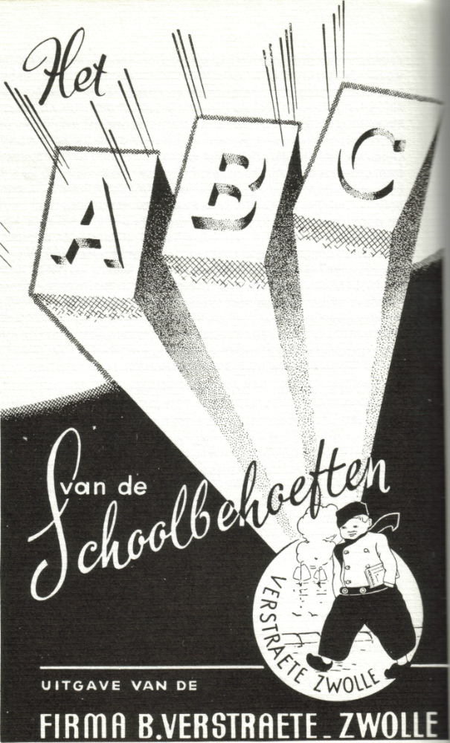

conferences and teachers' conventions. In my work I met and made deals with intellectuals instead of with people who disliked or lacked interest in education. I had the privilege of meeting with leaders in industry and commerce and with highly placed government officials, having the most interesting discussions, and making important decisions and profitable deals. Then again, I have been asked the question many times, "For pete's sake, why did you leave that all?" The answer is not so simple to give. On the other hand, it can be quite easy to explain. In a way I was more or less sick and tired of the Dutch way of life. With a large family living in cramped quarters and with a small possibility to make much improvement therein, with government interference in business making it impossible to conduct the affairs of our family business the way we wanted it, things had become less and less attractive. Holland is most favourably known for its freedom of religion, education, politics, and other spiritual values. The country's disadvantages, however, include its bureaucrats sticking their noses in every way of life and business and having the power to kill free family enterprises. Their regulations determined whether we could expand our business or not, they decided if our company could hire and fire, thus setting conditions, quotas and prices for almost everything. Under such conditions we longed for a land that would encourage its people to go in business, supporting and congratulating them when things go good, and blame nobody but the boss and owner when business went bad. Canada was told to be a land like that. We were never disappointed in the country.

The climate in the region of Canada we came to is very attractive to us. Although Holland is said to be a frog land, it has its many beautiful places and seasons, too. It was not for a change in the climate or weather when we came to Canada. There as well as everywhere else, rain, cold, heat, storms have to be met as they come and should never interfere with or determine happiness. In both countries we lived in, we needed heated houses during the winter time, rain-coats and rubber shoes and shelters against storms. In both countries we have experienced floods. In both we have had colds as well as sunburns.

Canada has above all room to live and breathe. In Holland it's very compact in living quarters. Now we live with others in Canada at an average of about five persons per square mile. In Holland it was more than a thousand persons. We were very fortunate with the last house we had in Holland, a house which had a small yard in the front and back as well as on one side of it. Our former next-door and upper-story neighbours were not so lucky and many of them didn't have anything private outside of their homes. Such people were most happy when they were sitting during sunny days on our grass in front of one of our bedrooms. And that part of our lawn was less than twelve feet square. You'll understand why we now still like driving with the family car through the countryside, looking left and right and enjoying how great Canada is in its physical aspects.

We had pulled up stakes in a country in which we had roots well grown and established. Now we have settled in a part of Canada which we like very much and we arc living among people who are good to us in many ways. Our children have grown up, making their own way of life. Canada has been good to our children, too, giving them the full advantage of good education, the results thereof seen in their enterprises and professional careers and the freedom to live their own lives. They have settled at various places in Canada. Those born in Holland have still good memories of the old country they came from via the s.s. "Waterman". They have visited Holland again, and with the youngest one born here, together they were brought up to be proud Canadians. Our seven children, five of them married and having brought their spouses into our family, and our one dozen grandchildren are all happy and healthy. We have many reasons to be thankful for the things we have been given in Canada, and we are.

Half a dozen and one extra -37-
Half a dozen and one extra. That is my wife's and my children. My wife had carried and given birth to all the babies who immediately became a Verstraete. She had become a Verstraete by marriage, but as the mother of our family she's always been a most important one to all of us. I like you to meet her first, here and now.
My wife, our mother and grandmother.
Before the Second World War, my father had a good friend who was the principal of a school which had hired a teacher who was introduced to my father's family that included me. That teacher and I liked each other, fell in love, became engaged, got married, and had children. She was Cornelia Van Dam, from Gouda, the Netherlands, the well-known city of Gouda cheese, candles, pottery, and St. Jan's Church whose unique stained-glass windows are world-famous and in which church Cornelia as a baby had been baptized. A daughter of Gerrit Van Dam and Adriana Van Der Dool, my wife had three brothers and a younger sister. A step brother and sister were from her father's second marriage, which took place after my wife's mother had passed away within a week after her last baby girl was born.

My wife's ancestors comprise a line of fine building trade craftsmen in the Gouda district and as such have been traced back to the years in the early 1700's. The Van Dam family records show how fragile young lives were in the days of old. Without sufficient immunization against smallpox babies died in great numbers before they were one year old. My father in law had been the third Gerrit in his parents' family: the two other small boys named Gerrit also, had died of smallpox when they were still very young. An honest, hard-working man, my father-in-law is remembered as the always busy partner in a family construction company. He loved fishing and hunting so much that most often after work he would come home with fish, birds, and other game, even if they were caught under circumstances when hunting and fishing laws would not legalize his actions. He had spears for catching eel and fish and saw them many times confiscated, but authorities didn't lay charges too often because he did the hunting so honestly and never in a hidden way. During the war years he continued his hobby and he would bring home every kind of food he found, distributing it unselfishly among the people with the greatest need.

In her younger years my wife had attended the Da Costa School for elementary education in Gouda. In 1933 she had graduated from the John Calvin Secondary School, also in Gouda, where she had been able to skip a complete grade. In 1936, again after skipping a grade, she graduated from Teachers College in Schoonhoven, South-Holland. It was a four year training course but after three years she was able to finish school with the highest standing marks. Our eldest son, Beert, accomplished the same in high school in Canada, skipping one year and finishing first, thereby showing he had inherited this ability to absorb knowledge from his mother. My wife had also taken courses in fine needle work and knitting for which special credits were given on the back of her teacher's certificate.

Before our marriage my wife had taught schools in Gouda, Zwolle, and Ouderkerk on the Ussel River. During our marriage, she found time for and pleasure in writing stories, which were published regularly.
Beert.
Our eldest son and first-born child, Beert, was born on a Sunday morning in the Sophia (General) Hospital in Zwolle with a gynaecologist, Dr. Ten Brink, taking care of the delivery. When the time for the baby's birth had come, my wife and I hired a horse drawn carriage to go to the hospital. The carriage driver had a normal taxi permit and a drivers licence, but the German occupation under which we then lived was the cause of the disappearance of all motor vehicles for civilian use. I'm quite sure that even the horse and the carriage had ceased to exist before Beert was less than one year old. Such things as food and fuel were gone during the last war winter.

Beert's early years were eventful. Once, we remember, his cradle was filled with broken glass falling from windows as a result of airplane bombing, but fortunately Beert was in his mother's arms elsewhere in the house. Beert's ability to learn was revealed already in his very early years. Before kindergarten age he could identify all colours, was able to read and write a little, and do simple mathematics. His mother was an experienced school teacher and took pleasure in teaching her young children before somebody would start to look after this in school. Beert's first elementary school year was at the Da Costa School in Zwolle, but problems with his teacher on account of his being left handed, made us decide on a transfer to the Queen Wilhelmina School, also in Zwolle. After completing grade six Beert took two years education at the David Wijnbeek Secondary School before we left for Canada. Beert was baptized Beert Christiaan in the Plantage Church, Zwolle, his names in honour respectively to his paternal grandfather and great-grandfather.
Gerrit.

Gerrit was born also on a Sunday morning, about a year later, one day after we were liberated from the German oppressors. There was no possibility then of going to a hospital because during the night before his birth we were under German artillery fire. The birth took place in our home, Rozemarinstraat 1, with partly boarded up windows, the glass had gone during war bombings. The gynaecologist, Dr. Weber, who lived almost next-door to us, took care of the delivery. A fact to remember is that Gerrit, even before he had received that name, and within a second after his birth, relieved himself and wetted his mother a good deal. Our city of Zwolle was these days in a festive mood and then during the night and previous day Canadian soldiers who had arrived were made welcome with music, street dancing and invitations from people. Two soldiers paid us several visits and, when the baby was named Gerrit, their names were added - Vincent and Leonard. Gerrit's baptism took place in the Ooster (East) Church, and the baby was named after his maternal grandfather Gerrit (Van Dam) and after the two Canadians.
At an early age Gerrit and also his brother Beert had shown great interest and abilities in art and the two young brothers, aged three and four, became students at Zwolle Fine Art School "Het Hopmanshuis". Like his brother Beert, Gerrit went to the Queen Wilhelmina School and the David Wijnbeek Secondary School until we emigrated.
Lida.
When Lida was born we had moved to Enkstraat 62 and there, in a bedroom, the delivery took place with Dr. Ten Brink in charge of things. Lida was not so much in a hurry to come, and for that reason the doctor had sent me to his home office for a 'piton' injection needle which could speed up the birth process but which needle he had not taken along. Within half an hour I had come back with what the doctor needed, but Lida was there already.

Lida went to classes at the Queen Wilhelmina School and the Elout Van Soeterwoude School before we went to Canada. She was baptized Aleida Anneke in the Zuider (South) Church in Zwolle. Her names were to honour her maternal grandmother Aleida Verstraete, nee Admiraal, and her maternal great-grandmother Annigje Admiraal, nee Dekker. With her always curly hair and brown eyes, Lida was always most lively. In her third year she unfortunately contracted scarlet fever and was, during the time of her serious illness and her convalescence, nursed, under direct doctor's control, by my wife. Isolated in a room of the house, everything that went in and came out was sterilized and Lida recovered completely although a small scar has stayed as a visual mark showing the seriousness of the illness she had. Lida always had liked to talk with friends and other people and once, at school, she earned and also received a one hundred percent mark on her grade five report card for a subject which she always liked so much - talking.

Baldwin.
Baldwin came to us on a Friday evening. The summer months had been extremely hot, and my wife had become tired from the pregnancy and the extra weight she carried. Fortunately for her, just before the baby was due the weather changed and our third boy was born during a cool week. Dr. Ten Brink again was the man we trusted for the delivery. The living room of our Enk Street home had been transformed into a small private delivery room and there Baldwin was born, 54 cm tall, almost ten percent more than an average birth length.

Boudewijn, as his original name was, was smart at a young age already and he is well remembered for his willingness to help other people. At the age of four, he did grocery shopping at neighbourhood stores for his mother who had then her hands and hours fully tied up with a large family. Baldwin was baptized in the Zuider (South) Church. We had pleased the grandfathers with the traditional naming of children after grandparents. For the new baby boy we freely choose the attractive names Boudewijn Alexander.
Annelies.
On a Wednesday afternoon Annelies was born in the Roman Catholic Hospital in Zwolle. When she was due and my wife was in the maternity ward, the births there were processed almost like mass production. The delivery room was constantly in use and a next-door large hospital bathroom had been made an auxiliary delivery room and an ordinary ward room likewise. Expecting mothers were attended to like at a store's checkout: who's next.

Like the other children born to us before, Annelies was a healthy baby and she grew up fine. In due time, she went to kindergarten and elementary classes of the Queen Wilhelmina School as her brothers and sister had done before. About Annelies we remember one special night during her second year. We woke up during that night as a result of noises in the kitchen. Thinking about thieves, my wife and I went carefully out of bed towards the kitchen and found there Annelies. Sitting on the floor, she was eating cookies from a jar which had been in the cupboards. She had known that, and after waking up during her sleep she had left her bed for it. Her eagerness to look for things to eat or drink had brought her at one time in a perilous situation. Finding a bottle with household ammonia, she tried to use some of it and had her mouth and tongue very badly burned and turned blue from the contraction of her throat. With milk as first aid she survived that accident. Annelies was baptized Adriana Elisabeth in the Zuider (South) Church and was named thus in honour of her maternal grandmother, Adriana Van Dam, nee Van Der Dool, and her grandmother's sister Elisabeth Stuurman, nee Van Der Dool.
Going to the Queen Wilhelmina School, our children didn't have to go far. The school had no field of its own and during recess and before school started the students entertained themselves on the streets and on a fair-sized public square. There was a band shell in the park's centre, surrounded with grass and large linden trees. The square was enclosed by streets on which were located three schools: the Queen Wilhelmina (a Christian) School, a Public School, and a teachers college plus many houses and stores. One of the Queen Wilhelmina School's side walls and the side wall of the house we lived in were next to each other, so close that there was not even an opening in between. The exteriors of the school and the house had been designed by the same architect and had all been completed at the same time, as part of Zwolle's oldest suburb, Assendorp. Our children could not have had another school closer by. Nobody could. For, in fact, the side walls of our home and the school's were of one solid construction, we living on one side of the wall and children being taught on the other side of it.

Shortly after for us the war was over, we were grateful and content to have our Enk Street home. The Rozemarin Street home in which we had lived temporarely during the war years, was originally built hundreds of years back as the rectory of a nearby church. The building contained, among other things, a ground-floor hallway with eighteen doors leading to many and various rooms and other parts of the building's first floor, including a vestibule with a white marble floor; the second story hallway had half that number of doors giving access to seven more large rooms; the third or top story was one large and completely finished area without partitions. All of it had been well-built with double-thick brick outside walls, full brick inside walls, solid oak double thick floors and beams, matching doors and windows with real, indoor and built-in-the-wall window shutters-a house originally made with no shortcuts in the construction. It had also been used as a place for lodging and entertainment of distinguished guests of the church. It was a part of a whole complex of buildings which included a next-door, but only via the courtyard accessible large dining hall for special occasions, a beautifully finished chapel with stained glass windows, and more rooms for work, study, leisure and sleeping of peope. The buildings were abandoned by the church when a new centre was built. Then it served for many years as a friary until after the First World War larger buildings were needed for that purpose, too.

Only the south side of the Rozemarin Street house gave an attractive living with the access to the enclosed garden with trees, galleries, and flowers. For the rest, the house was literally as well as figuratively cool during the summer months, and with no adequate heating during the rest of the year it was a cold edifice only good for business purposes: offices, showrooms, workshops, and warehouse. The rooms we had occupied during the first years of our marriage were needed again for the family business. With our two first children, we were glad to move out and although our Enk Street home was small and lacked many things which at later years would have been taken for granted in every normal living space, we found it then attractive enough to move into it. The new place had also the picture window boarded up with wood and cardboard because there too, the glass was gone during war bombings and new glass in large sizes was not available until after we had moved.

The back yard was small and adjoined several other 'gardens'. The combined open space between the houses' back walls could not have been larger than approximately sixty by sixty feet square. It was enclosed by a couple of dozen residences, some stores, and two schools. At a large part of the enclosure the sun could never reach the black and damp soil. As a result many walls and a part of the ground were continually covered with a thin coat of moss-like, green lichen. The patio which our house had was large enough for two people to sit upon a chair, but one had to move out when a third person also wanted some fresh air on the patio. But, in that * small house we all enjoyed the friendship with the many neighbours we had. We even saw there an opportunity to raise some young roosters in a self-made henhouse. However, the noises the roosters every day made at sunrise made us to decide, after only a short time had lapsed, to have some extra meat on the supper table. And having already an offspring of five, still another baby was born to us in that house.

Sylvia
Making half a dozen complete, Sylvia was born in our Enk Street home on a Tuesday morning. The medical assistance was secured from our family physician, Dr. Hueting. A special nurse was also booked well in advance of the event. When the time was there, the doctor came upon my calls but the nurse slept in, not showing her blushing face until after Sylvia was born. It was the only time I had to assist directly to my wife and the doctor as a midwife-man.

When Sylvia grew up, but was not yet at kindergarten age, my wife took up teaching again and carried along to the schools the little Sylvia. In a children's seat on the back of a bicycle, Sylvia was taken to several schools where my wife would temporarely teach classes when regular teachers were absent on sick leave. At these times baby sitting services were unknown and the solution was found in taking Sylvia along and let her play and have an afternoon nap in the classroom. As the result of an enormous shortage in teachers, it was allowed by the schoolboards my wife worked for. The students in the classes loved it, and Sylvia always behaved like a good girl. As parents we had her baptized with the name Sylvia. The event took place in the Zuider (South) Church. We had found the name so fine and attractive that no middle name was added to it.

It had been busy times then for our family. At nine o'clock in the morning everybody was gone to school. Some to study, one to teach, one to play and sleep, and one for business.

We were most lucky with the house we had in a land where attics were partioned to make extra homes. Immediately after the war, the need for houses was unbelievable, and that had hurt the happiness of many people who could not find a house. For young married couples waiting lists were officially kept up at city hall. The couple's combined years of age had to be very high before consideration was given to their application for private living space. In that time of shortages we were lucky indeed to have a home with two bedrooms completely for ourselves. We became even more fortunate when, after trying and working hard on it in every way possible, we got hold of a larger, sunny, and new home on the Abel Tasman Street, at the city's outskirts. Through the front windows of that house we could look over meadows and open fields. Around the house we had on three sides grass and a garden, and the sun could reach us all day when it was shining. Compared to our former home the place was large but for our family of eight it gave still a very compact living space. Clouds on the horizon included the fact that all the beautiful land we could look at was designated as building grounds. We have left from that house on the Abel Tasman Street for Canada. Since then the land we could look over, has been filled with high rises and other large buildings. That has taken away there from the people presently living there the possibility to see the sun set. But that was not our concern any more. Then we were seeing the sun in Canada.

Ingrid.
With a wealth worth more than spoken and written words can express my
wife and I came to Canada - half a dozen healthy children. Three sons and
three daughters.

In the new land once more we were given a reason to rejoice in the birth of a
healthy girl, Ingrid. She is a one hundred percent member of the family but,
as she was born after we came to Canada, she has caused this part of my
book to be called 'half a dozen and one extra'.

As two happy parents we had come to Canada with six children. Ingrid
became the only one of us to be born here, namely in the third year after our
immigration and at the Sydenham District Hospital in the Gore of Chatham,
now Wallaceburg, Ontario.

Our family physician, Dr. Marvin L. Booth, was in command in the delivery
room, Our last born baby was baptized Ingrid Caroline in the Wallaceburg
Christian Reformed Church.

Canadians by choice and by birth -47-
Together with us, very many emigrants left their old country. In the years before and after also, thousands upon thousands have done it, coming from many countries to Canada. We made a completely free decision to leave Holland and everything behind us and to look for new lives in a new land. For all eight of our family it has been the greatest event in our lives - when we arrived in Canada after all the considerations, we had burned the ships behind us. And because this turning point in the history of our branch of the Verstraete family was so important, I have found it a good idea to write down many memories in connection with it.
For the coming generations of our family it might be interesting to know where they came from, read how several things had happened, and why. We have never been sorry to have made the enormous decision to emigrate from Holland, to come as immigrants to Canada, and live in the new country. That decision has been of a great influence on the children's lives also, but when I look at one after another, I say they all are basically happy, prosperous, and content. I realize that life is not all honey, but when given faith, hope and love, difficulties will be easier to bear when they come to us.
We have met many other immigrants, from all parts of the world, some people with high hopes but with slow progress in materializing their hopes. We have met others, also with hope - no immigrant comes without it, but they lost head and senses, with hope turning into greed. When good luck knocked at their door they would lower, even disband moral standards for a step-up on the ladder which they thought that would bring success.
We have met honest, hardworking people who accepted material gain as a blessing given to them, even if they had worked hard for it themselves. We have been an immigrant family among so many other. We have been disappointed with things during the first years of our immigration, and with people too. Now we are Canadians, proud to be so and have all the privileges and obligations going with it. We have made friends with men and women born here and elsewhere - friendships we very much appreciate.

Many times old memories flash by and things of the past are compared with things of the present, comparisons good and bad. When, at the end of my years in elementary school in Holland, my father and I had an interview with the school's principal to discuss my future study possibilities. I remember it so well (the fact has happened over forty years ago now): the principal was favouring the idea and suggestion that I should continue in fine arts on the basis of the progress I had made in his school. But in the early thirties, in the middle of a world-wide depression, there were no reasons to nurse the idea because fine art would not even bring dry bread for a living, and an expensive study for it would be considered a senseless throwing away of money then so hard to get.

Instead I went to a secondary school for some time, then became involved in the family business, took up studies again and followed the city of Zwolle's business college. After that I studied courses in advertising, design, graphic art, advanced business management, and psychology. Now, after looking sofar back, it is actually good to see that many of our children have inherited the same interests in life, some even making a career out of it. My wife's extraordinary memory and the application thereof in study and life, is also seen as a heritage to some of them in relation to their careers. All our children have given us, as parents, many reasons to be proud and thankful for. They were children when we had left Holland for Canada. Then, during their teens and the years of being young men and women, we have seen them to develop into strong individuals. Now, the half a dozen which we came to Canada with, have left their parents' home as their place of residence and they are another step further in life - men and women in the full strength of their lives, living independently, five of them with fine families, one as a bachelor. They live now in houses and in a life-style most people in our old country Holland would be envious to have.

Canada had been good to us. All of us live conveniently, contentedly and enjoy good health - things so often taken for granted but for which we always are very thankful.
Canadian immigration laws had stipulated that persons who had legally entered Canada as landed immigrants, had to wait five years before they could apply to become Canadian citizens. For our Ingrid that law was not applicable, she was born a Canadian. For the other members of our family it was the thing we had been looking forward to, a possibility not to be deferred. In March, 1964, in Chatham, Ontario, during a special session of the court of Canada and with a ceremony complete with pomp and splendor, the Verstraete family which had immigrated from the Netherlands, with the hands on the bible, swore a true allegiance to Canada, its Queen and her heirs. Then and there ended for us the status of landed immigrants. We abandoned the privileges of Dutch nationality and received the official documents that certified that we were Canadian citizens under the provisions of the Canadian Citizens Act and, as such, were entitled to all rights and privileges and (of course) were subject to all responsibilities, obligations and duties of a Canadian citizen. As witnesses for us had stood up two Canadian-born friends, both of Wallaceburg, Ontario.

In order to comply with the requirements for a significant scholarship which was granted to him, Beert had been given the opportunity to become Canadian citizen ahead in time of the other members of the family. He was sworn in without any special ceremonies in the court house in Chatham, Ontario, in February, 1963, and became a Canadian as it were 'over the counter', from underneath which a bible was produced to complete the simple rite.

The official procedures for becoming Canadians was for us a natural result of our desire to emigrate, nursed many years back in time. Actually it was the end of the Verstraete venture, because what then followed was not anymore all that special a course of action and an undertaking that contained much risk. It had become a Canadian life with its ups and downs as for every other Canadian. After our planning of emigration, and then pulling up stakes and roots, we had landed in Quebec as well in Montreal and were first stranded in a farmers' land.
With half a dozen children who were born in Holland and with one born in Canada, we had overcome the difficulties which had lain in store for us. As Canadians by choice and by birth, we had done well and now are proud to be citizens of the country that is good to us - Canada.

Index of Pictures -51-
1. Within an hour after we had first set our feet on Canadian soil
we had a most pleasant picnic in a Montreal park. Page 10
- During the first winter in Canada, our children could skate up to
the back door of our first house in Wallaceburg, Ontario. Page 14
- The ferry to Walpole Island, which I had to use for going to my
first job in Canada, was a contraption as I had never seen before.
Page 16
- An irrigation system near the field I worked on during the first
days we were in Canada, was fascinating for me who had seen
land arise out of the sea. Page 17

5. The first sign of an industry in Wallaceburg nobody there had
ever heard of before - bookbinding. Page 19

6-7. The new bookbinding industry in Wallaceburg had grown to a good size business. The business inside and outside as well as its corporate image had been designed by a Verstraete. 8-9. Dignitaries from the Netherlands would drop by to compliment the work being done. Shown are the Honourable B. Roolvink, Crown Minister of the Neherlands and I, and a newspaper article. Page 20-21
8-9. Dignitaries from the Netherlands would drop by to compliment the work being done. Shown are the Honourable B. Roolvink, Crown Minister of the Netherlands and I, and a newspaper article. Page 22
10. At the Montreal harbour waiting for departure from the s.s. "Waterman". Page 23

11. Figuratively and in fact my father had laid the cornerstones for
the new Wallaceburg enterprise. During a visit to Canada he laid
the 'first' stone for the Arnold Street shop. Page 24

12. Our six Dutch born children together with their paternal grand
parents at their cottage on the Veluwe, the Netherlands. Page 29

13-14. After the Verstrate family business building had been destroyed by a fire and had burned down to the bare walls, the family enterprises had arisen again and after the war had grown to a country-wide known company. Photo Zwolle Newspaper, March 21, 1934, and a front cover of the Verstraete-Zwolle quarterly for sales promotion and public relations, issue nr. 14, September, 1948, with the company trade-mark incorporated. Page 31 and 34
15. My wife in her early years (standing left) with her parents and three brothers. Page 38
16. Beert en Gerrit, at such tender ages, went together to art school.
Picture taken in front of our Enk Street home. Page 40

17. In front of our Abel Tasman Street home, together with my
parents shortly before we left for Canada. Page 45

18. The extra one, born in Canada. Ingrid at a young age with a
sister's guitar. Page 49

19. The Verstraete family crest. Page 54
20. Gouda City Hall where my wife and I were married. Ink drawing
by my wife's father. Page 57

21. The Admiraal family crest. Page 59

Appendices - 53-
1. The Verstraete line of heritage and the Verstraete family crest
2. The Van Dam line of heritage
3. The Admiraal family crest and a description thereof
4. Notes

Appendix 1

The Verstraete Family
The line of our descent as Verstraete traced back through parents, grandparents, etc. has been followed back into history as far as the early seventeen hundreds.
Far from being a complete genealogy, in some recorded cases the facts may not even be as accurate as they are shown to be.
I Livinius Verstraete
Married Franciska Bobelyn
Lineage continued via a son, Jean
II Jean Verstraete (1744)
Married Angelica Steyaert(1748)
Lineage continued via a daughter, Caroline
III Caroline Verstraete (1787)
Married Livinius Leonardus Roegis
Lineage continued via a son, Bernardus
IV Bernardus Verstraete (Feb. 1, 1806)
Married Christina Dijkstra
Lineage continued via a son, Bernardus
V Bernardus Verstraete (Oct. 30, 1836)
Married Jansje Vach (Jan. 18, 1834)
Lineage continued via a son, Christiaan
VI Christiaan Verstraete (Jan. 4, 1866)
Married Hermina Hoksbergen (Sept. 30, 1866)
Lineage continued via a son, Beert

VII. Beert Verstraete( July 25, 1893) Married Aleida Admiraal (April 4,1891) Lineage continued via a son, Christiaan Other children: two

Lambert Verstraete (March 1,1922), Married Rikje Witke (Jan. 23, 1922)'
Herman Verstraete (Sept. 13, 1926), Married Truus Plug (Oct. 4, 1927)

VIII. Christiaan Verstraete (June 27, 1920) Married Cornelia Van Dam (March 11,
1918)

Children:

1. Beert Christiaan (April 2, 1944, Zwolle
2. Gerrit Vincent Leonard (April 15, 1945, Zwolle)
3. Aleida Anneke (May 9, 1946, Zwolle)
4. Boudewijn Alexander (July 4, 1947, Zwolle)
5. Adriana Elisabeth (March 16, 1949, Zwolle)
6. Sylvia (April 3, 1951, Zwolle)
7. Ingrid Caroline (Nov. 22,1960, Wallaceburg)
At the time of the compilation of this book the seven children of Christiaan and Cornelia Verstraete have the following status
1. Dr. Beert C. Verstraete, Professor
Department of Classics, Acadia University, Wolfville
Nova Scotia
Living in Wolfville, N.S.
Not married
2. Gerrit V.L. Verstraete
Executive Vice-President, RVHA Advertising Ltd., Toronto Ont
Married Alice Koops (June 26, 1948)
Living in Port Credit, Ontario
Children:
Jeffrey Lyon(Nov. 7, 1968)
Wendy Caroline (Feb. 6, 1972)
Angela Miriam (July 8, 1976)
Karen Elizabeth (September 19, 1979)

3. Aleida Anneke Verstraete
Married Mathew William Boyle (Jan 12, 1934)
Living in Bright's Grove, Ontario
Children:
Julia Christine (Nov. 20, 1969)
Mary Lisa (Nov. 29, 1974)
4. Boudewijn Alexander Verstraete
President, Valentine Travel Service, Ltd., Toronto, Ont.
Married Lucy Gabrielle Munneke (Nov. 22, 1946)
Living in Don Mills, Ontario
Children:
Christiaan Alexander (May 15, 1974)
Liane Gabrielle (Feb. 26, 1976)
5. Adriana Elisabeth Verstraete
Married Jack Wallace (Oct. 3, 1947)
Living in Sarnia, Ontario
Children:
Jennifer Nicole (Mar. 18, 1973)
Jason Arthur (Dec. 24, 1975)
6. Sylvia Verstraete
Married Donald Charles Rose (Jan 2, 1949)
Living in Sarnia, Ontario
Children:
Shawnda Lynn (Oct. 21, 1976)
Lindsay Ann (Apr. 14, 1979)

7. Ingrid Caroline Verstraete Student Lambton College, Sarnia, Ontario Living in Point Edward, Ontario Not married

Remarks on the Verstraete family lineage

1. All data given in brackets refer to births only.

2. Roman numerals preceding persons' names indicate the generation standing as it had continued from the first on record.
3. The last two generations of the Verstraete lineage could have been marked IX and X since they are the ninth and tenth generation in that succession. However, they don't have it.

Appendix 2.
The Van Dam family
A family line as far as it can be traced back.
I, Jacobus Van Dam (1744)
Married Adriana Langerak (1744)
Lineage continued via a son, Gerrit
II. Gerrit Van Dam (1786)
Married Margrieta Lekkerkerker (1781)
Lineage continued via a son, Jacobus
III. Jacobus Van Dam (1824)
Married Neeltje Baartman (1822)
11 Children, 3 survived early childhood
Lineage continued via a son, Dirk
IV. Dirk Van Dam (1849)
Married Cornelia Huisman (1853)
13 Children, 5 survived early childhood
Lineage continued via a son, Gerrit
V. Gerrit Van Dam (Jan 14, 1890)
Married Adriana Van Den Dool (Sept. 10, 1892)
Children:
Dirk (Nov. 14, 1912)
Gerrit (April 19, 1915)
Cornelia (Mar. 11, 1918), Married Christiaan Verstraete
Jacobus (Mar. 26, 1920)
Sijgje, Nel(Apr. 23, 1922)
Gerrit Van Dam (1890)
Second marriage: Annigje Broere (June 19, 1886)
Children:
Jannigje(Dec. 12, 1928)
Cornelis (Mar. 7, 1933)

Remark
All data given in brackets refer to births only.

Appendix 3
The Admiraal Family
The Admiraal family (see Appendix 1, generation VII) received their family name the following way.
In October, 1573, Cornelis Dirkszoon, burgomaster of the town of Monnikendam (located a few miles north of Amsterdam), was the hero of the Battle of the Zuiderzee during the revolt of the Netherlands against Spanish rule. Captain of a warship in the naval force mustered by the rebels, he captured the Spanish flagship "The Spanish Inquisition" and took as his prisoner de Bossu, the enemy commander; following his moral and symbolic victory for the Dutch, the entire Spanish fleet was defeated and destroyed. Cornelis Dirkszoon was consequently honoured for his bold feat with the rank of Admiraal (Admiral); and his descendants adopted Admiraal as the family name together with the hereby illustrated family crest.

Appendix 4
Remark
This book is not a complete record of family history. The story of the
Verstraete family will not end as long as Verstraete children grow up and
become parents too.
The following blank sheets are added to this book to make it possible to enter
personal recordings of additional facts which are or will become of interest to
the whole family or branch thereof.
Notes

25

